IPD File for BlackBerry
By lff0305@gmail.com

V0.1

Please get the latest version from http://code.google.com/p/bbipd/

Chapter 1 General Structure
An IPD file can be considered as a database collection. When you backup data to an IPD file from RIM Blackberry Desktop Manager, data on the phone is saved into one or more databases. Each kind of data is saved to one database. For example, all SMS(Short Message Service) data is saved in Database named by SMS Messages.

The IPD file contains the following part:
The file header : The header of the IPD file. The signature, version data are in this part.
The Database Name Blocks: Several blocks containing the Database names.
The Database Records: Several records contain the real data.

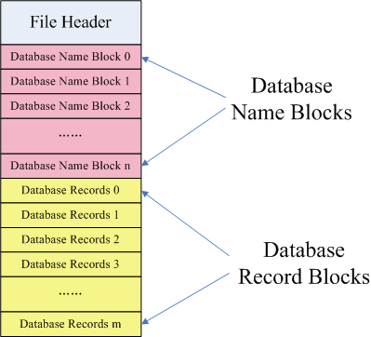

Chapter 2 File Header
File Header is a small piece of data. It has the following data:
RIM Signature
LineBreak
Database Version
Numbers of Databases in current file
Database Separator
Name | Length | Offset | Description
RIM Signature | 37 bytes | 0x0 | RIM signature:The ASCII of Inter@ctive Pager Backup/Restore File
LineBreak | 1 byte | 0x25 | 0x0A. Seems not used.
Database Version | 1 byte | 0x26 | In recent versions of BlackBerry Desktop Manager this field is 02.
Numbers of Databases | 2 byte | 0x27~0x28 | How many Databases are in this file
Database Separator | 1 byte | 0x29 | 0. Seems not used.

The following is an example from a real .IPD file.
00000000h: 49 6E 74 65 72 40 63 74 69 76 65 20 50 61 67 65 ; Inter@ctive Page
00000010h: 72 20 42 61 63 6B 75 70 2F 52 65 73 74 6F 72 65 ; r Backup/Restore
00000020h: 20 46 69 6C 65 0A 02 00 71 00 15 00 56 69 73 75 ; File...q...Visu

RIM signature LineBreak Version Number of Databases Database Seperator
Sample (1) File Header

Chapter 3 Database Name Blocks
Database Name blocks are after the Header part and they matched with DatabaseNumber value in Header part. For example, from the Sample(1), the number of Databases is 0x 00 71. So the numbers in current database will be 7 * 16 + 1 = 113:
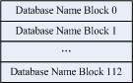
Total 113 Database Name Blocks
In each block ,the following data is saved:
Name Length
Name (Including Terminating NULL)
Name | Length | Offset From start of Database Name Block | Description
Name Length | 2 bytes | 0x0 | The length of the Database Name including NULL as Little Endian
Name | NA | 0x2 | The NAME and Terminating NULL

The following is an example from a real .IPD file.

00000000h: 49 6E 74 65 72 40 63 74 69 76 65 20 50 61 67 65 ; Inter@ctive Page
00000010h: 72 20 42 61 63 6B 75 70 2F 52 65 73 74 6F 72 65 ; r Backup/Restore
00000020h: 20 46 69 6C 65 0A 02 00 71 00 15 00 56 69 73 75 ; File...q...Visu
00000030h: 61 6C 20 56 6F 69 63 65 20 4D 61 69 6C 20 3F 3F ; al Voice Mail ??
00000040h: 00 12 00 50 69 6E 79 69 6E 20 49 4D 20 6F 70 74 ; ...Pinyin IM opt
00000050h: 69 6F 6E 73 00 18 00 41 70 70 6C 69 63 61 74 69 ; ions...Applicati
00000060h: 6F 6E 20 50 65 72 6D 69 73 73 69 6F 6E 73 00 16 ; on Permissions..
15 00 : Name Length 56 69 : Name
Sample (2) Database Name Blocks

This example shows 3 Database Names:
(1) : Length = 0x 00 15 = 21 (In file it is 0x 15 00 and it is saved as Little Endian. So when converting to an int, it should be 0x 00 15)
Name = Visual Voice Mail ??\0 (20 characters, 1 terminating NULL)
(2) : Length = 0x 00 12 = 18
Name = Pinyin IM options\0 (17 characters, 1 terminating NULL)
(3) : Length = 0x 00 18 = 24
Name=Application Permissions\0 (23 characters, 1 terminating NULL)

Chapter 4 Database Record Blocks

General data in Database Record Blocks
Database Record Blocks are after Database Name Blocks. Each ipd file contains one or more Database Record Blocks. It can be displayed as:
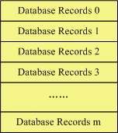
And each Database Record Block contains the following data:
Database ID
Total Record Length
Database Version
Database Record Handle
Database Record Unique ID
Database Fields
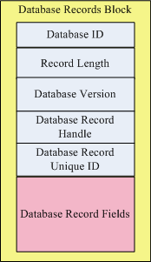
A Database Record Block
Name | Length | Offset | Description
Database ID | 2 bytes | 0x00 | An integer (Little Endian). The offset index of the Database Name Block to which this Database Record Block belongs. For example, if the Database ID is 0x 03 00 (3), then this record belongs to the Database which name is the 3rd in Database Name blocks.
Total Record Length | 4 bytes | 0x02 | The total length(Little Endian) of this record. We will discuss about it later.
Database Version | 1 byte | 0x06 | The version of the Database Record Format. Currently 0x05 is used.
Database Record Handle | 2 bytes | 0x07 | An integer for the record handle.
Database Record Unique ID | 4 bytes | 0x08 | An unique ID in the ipd file.
Database Fields | NA | 0x0c | Fields in this record. Will discuss later.

Database ID: So as described from the above table, from, we can know to which database this record belongs:
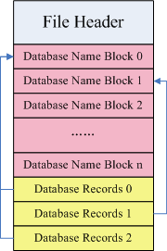
This example shows:

Database Record 0 ==> Database 0
Database Record 1 ==> Database 1
Database Record 2 ==> Database 0
Total Record Length: This field is a little complicated to understand. Let’s get it from one example. Assume we have a database record with 7 fields (For detail data in field, we will discuss later).
Field Number | Length
0 | 64
1 | 8
2 | 4
3 | 6
4 | 16
5 | 15
6 | 8
Total | 121
In this example, the total length of the records is 121 bytes. And each record, has a field header of 3 bytes. So the total length is 121 + 3 * 7 = 142 bytes. What’s more, the Database Version, Database Record Handle, Database Record Unique ID and Database Fields are all need to calculated. So the length is :142 + 4 + 2 + 1 = 149 bytes. And in ipd file, the length is saved as Little Endian as 4 bytes. So it is saved finally as 0x 95 00 00 00.
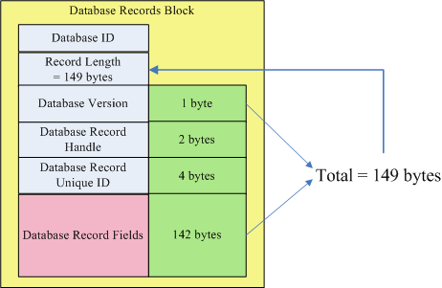
Record Length Calculation

Database Record Fields
One Database Record Block contain one or more Record Fields. One Database Record Field follows another Database Record Field. It can be showed as :
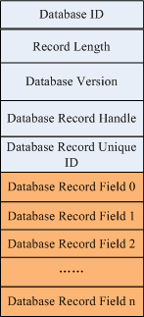
A Database Record Block with n+1 Database Record Fields
Database Record Field data is simple. It contains the following parts of data:

Name | Length | Offset | Description
Record Data Length | 2 bytes | 0x00 | The length (Little Endian) the field data in bytes.
Record type | 1 bytes | 0x02 | The type of the field data.
Record Data | NA | 0x03 | A serials of bytes containing the real field data. The length equals to Record Data Length

Note: The sequence of Database Record Fields may be important when restore an ipd file into the blackberry device. For example, a Database Record with Database Record Fields

Database Record Field 0 Database Record Field 0
Database Record Field 1 Database Record Field 2
Database Record Field 2 Database Record Field 1
Database Record Field 3 Database Record Field 3

This works. This may not work. So this Database Record may be ignored.

The following is an example of one Database Record Field:
00000000h: 0F 00 07 02 00 00 00 00 00 00 00 00 00 01 01 00 00 00
0F 00:Length 07:Type 02 00:Data
Length: 0F 00 convert to int as LittleEndian is 15. So the total length in data is 15 bytes.
Type: 07. This is used inside RIM. However, we can guess some of the type.
Data: 02 00 00 00 00 00 00 00 00 00 01 01 00 00 00. Total 15 bytes.

